Nexora website editor and publishing
Document 27 of the Nexora learning guides
Source snapshot 13 October 2026 at 17:12 UTC
Understand CRM-managed pages, design controls, media, revision history and publication.

Recognise the screen and its scope
Open /website. CRM routes use port 3017; member routes use 3018; public website routes can use 3019. Brackets name a route parameter, not text to paste into a browser. Choose a real record or site id from the application.
This guide covers Website creation and page list; Block editor and studio template; Layout colours typography and appearance; Per-block motion and hover controls; Media upload and scanning; Draft save preview publish schedules redirects and history.
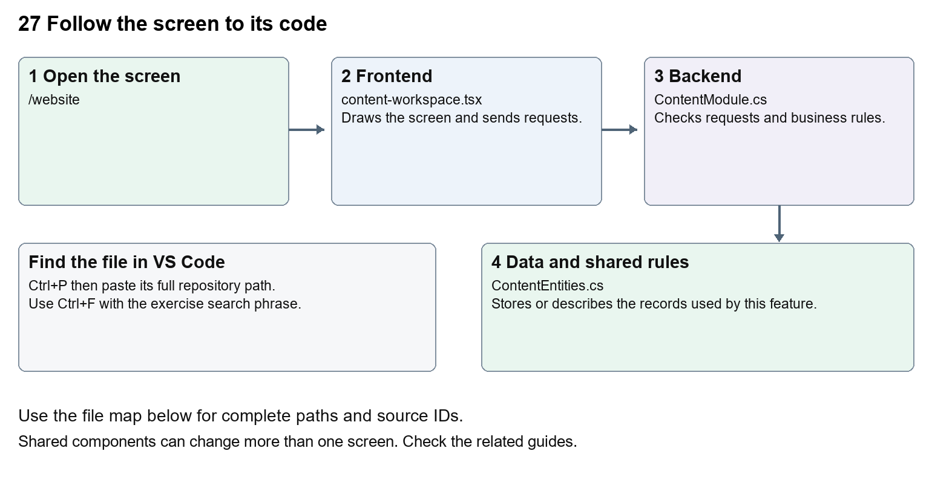
The diagram shows the file roles. The full paths below are what you paste into Ctrl+P.

Find the files in VS Code
Role | File and source ID | What it does
Screen | S0066 content-workspace.tsx | Main UI or route for this topic
Server | S0218 ContentModule.cs | Endpoints or server rules
Data | S0216 ContentEntities.cs | Data shape or persistence structure

Screen S0066
apps/web/src/features/content/content-workspace.tsx
Server S0218
backend/src/Modules/Nexora.Modules.Content/ContentModule.cs
Data S0216
backend/src/Modules/Nexora.Modules.Content/ContentEntities.cs
The complete HTML manual opens these source IDs inside its Source library. The Word manual shows short labelled extracts so you can learn the flow before reading large files. Each individual Markdown guide includes its complete primary files after the walkthrough.

Follow the request and the records
1. The workspace loads the site, page drafts, design settings and media.
2. BlockEditor collects structured blocks and their layout and motion.
3. Saving creates or updates a revision using the expected version.
4. An authorised publish or schedule action selects what visitors may see.
5. Public routes render published revisions and published design settings.

Read the code with an explanation
A page is a stored address and publication pointer; a revision holds title, description and blocks. A draft can change without changing the visitor page. WebsiteDesign and WebsiteMotion describe manageable design fields, not just hardcoded CSS. The editor and public renderer share types so the stored block data can be rendered consistently.
Source reference S0066 apps/web/src/features/content/content-workspace.tsx
Selected opening lines with their original numbers. The complete file is in the HTML source library.
0001 "use client";
0002 import { WorkspaceHeading } from "@/components/ui/workspace-heading";
0003 import { RecordListing } from "../shared/record-listing";
0004 import listingStyles from "../crm/record-listing.module.css";
0005 import { ArrowLeft, Plus } from "lucide-react";
0007 import { useEffect, useRef, useState } from "react";

The import lines lead to shared components and helpers. Start at the exported component or route function; follow the request helper to the server rather than assuming the whole feature lives in this file.
Source reference S0218 backend/src/Modules/Nexora.Modules.Content/ContentModule.cs
Extract from source line 33. A fragment from a long line is shown without the rest of that line.
0033 var api = endpoints.MapGroup("/api/v1/content").RequireAuthorization("content.read").WithTags("Content");

On the server, look for MapGet to load records, MapPost to create or perform an action, MapPut or MapPatch to change data, and RequireAuthorization for permissions. Some shared methods register endpoints indirectly. Find SaveChangesAsync to see the database write. A request method alone does not tell you every side effect.
Source reference S0216 backend/src/Modules/Nexora.Modules.Content/ContentEntities.cs
Selected opening lines with their original numbers. The complete file is in the HTML source library.
0001 using Nexora.BuildingBlocks.Domain;
0003 namespace Nexora.Modules.Content;
0005 public sealed class Site : TenantEntity
0006 {
0007 public string Name { get; set; } = "";
0008 public string Tagline { get; set; } = "";

Follow model fields to their request names and database mapping. An id points to a particular record. A tenant id limits the organisation. A version or concurrency stamp protects newer edits. Some model files describe contracts rather than tables; check the owning DbContext before assuming storage.

Make or trace your first change
1. Press Ctrl+P and open apps/web/src/features/content/content-workspace.tsx.
2. Press Ctrl+F and search for Create your association website. In this snapshot it appears at line 78.
3. Replace this empty-site form heading only. Inspect it only on a local site without saved content. For an existing website, use the block editor to preview draft text and discard it without publishing.
4. Replace only Create your association website with Set up your association website in that intended location. Keep quotes, tags, JSON keys and routes intact.
5. Save with Ctrl+S. Inspect Problems and the local screen. Review the diff and restore the original text when you finish practising.
Extract from source line 78. A fragment from a long line is shown without the rest of that line.
0078 className="text-xl font-semibold">Create your association website</h2><label className="block text-sm">Associa

These exercises have not been applied to the application. Their search phrases are verified against the captured source. Line numbers can move; the phrase and file path are your main navigation aids.

Check a change and diagnose problems
Confirm the original screen still loads, the changed words appear in the intended place, and another screen using the same component still behaves correctly. If an action fails, inspect the browser Network response, the relevant helper and server validation message. Use the common error table at the beginning of the manual. Reload on a version conflict instead of removing the version check.
A syntax error after a text edit usually means a quote, brace or closing tag changed. Compare your diff with the original. An unchanged browser result can mean the wrong port, a saved published configuration overriding a default, or a running API that has not reloaded.

Understand the current limits
Changing default template data does not overwrite saved pages. Clean media, permissions, domain configuration and publish state affect visitor availability. A page labelled Contact does not establish delivery of real enquiries.

Continue learning
Related guides 26 Nexora portal management, 28 Nexora public website, 29 Nexora documents evidence and file safety.

